
Report

Date | 21 September 2026
Team ID | MCA(Master of Computer Applications)
Project Name | Air Quality Intelligence: India Air Pollution Monitoring, Operational and Risk Analysis
Maximum Marks | 5 Marks

A report is a comprehensive document that provides a detailed and structured account of data analysis, findings, and insights. It is typically used for in-depth analysis, documentation, and communication of results. Reports are suitable for a diverse audience, including decision-makers, analysts, and stakeholders who need a comprehensive understanding of the data.
Designing a report in Power BI involves connecting to data sources, creating visualizations like charts and graphs, customizing their appearance and interactivity, organizing them logically on the canvas, formatting elements for consistency and clarity, and optionally creating dashboards for a summarized view. Throughout the process, it's essential to consider the audience's needs and ensure the report effectively communicates insights from the data. Finally, iterate based on feedback to continually improve the report's design and usefulness.

Observations drawn from reports in Power BI can provide valuable insights into business performance and trends.
1. Trends Over Time:
- Analyze how key metrics (e.g., sales, revenue, or customer counts) change over different time periods (monthly, quarterly, annually) to identify growth patterns or seasonality.
2. Performance Comparisons:
- Compare performance across different categories, such as regions, products, or departments, to determine which areas are excelling or underperforming.
3. Customer Segmentation:
- Assess demographic data (age, gender, location) to understand customer segments and tailor marketing strategies accordingly.
4. Goal Achievement:
- Measure progress against established KPIs (Key Performance Indicators) to assess whether business goals are being met.
Example:
- Gender Distribution:
- The gender distribution chart indicates that more Aadhar cards are issued to males (425,601) compared to females (247,174).
- Age Group Analysis:
- Among the issued Aadhar cards, the youth category (under 18) has the highest number at 464,000, indicating a significant focus on younger populations. This trend could suggest the need for policies aimed at youth engagement and benefits tailored for this demographic.
- Regional Disparities:
- The Central region has the highest sum of enrollment rejections (59,888), indicating potential systemic issues in that area. Addressing these concerns could improve overall enrollment success rates.
- High Aadhar Issuance:
- A total of 706,000 Aadhar cards have been issued, indicating strong enrollment efforts. The states with the highest issuance (e.g., Bihar with 162,407 Aadhar cards) should be studied for successful outreach strategies.

Report Observations (Air Quality Intelligence)
Observations drawn from the two report pages built for this project:

Report 1: Air Pollution Monitoring & Analysis Report
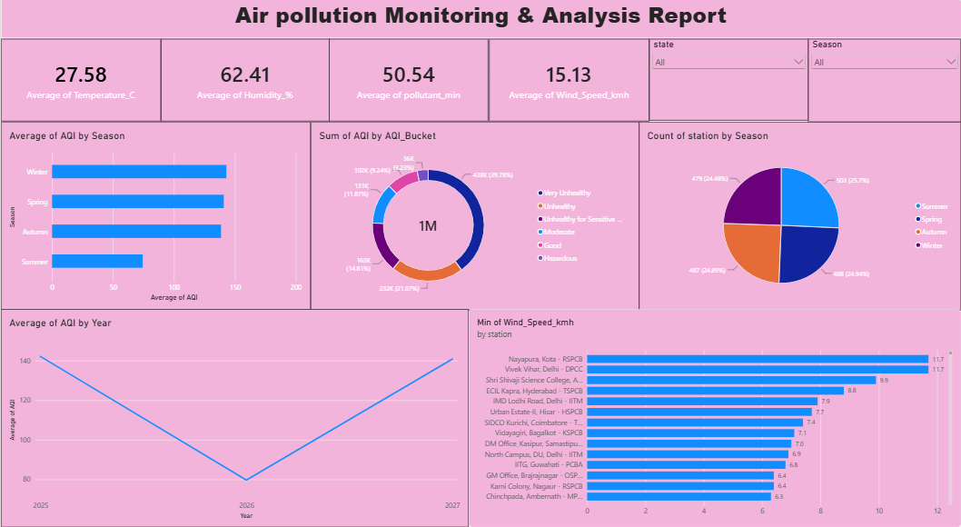
Trends Over Time: Average AQI by Year dips sharply in 2026 (~80, the chart's low point) compared to 2025 and 2027 (both ~140) — a V-shaped pattern worth validating as either a genuine improvement or a partial-year data effect rather than a real multi-year trend.
Performance Comparisons: Average AQI by Season shows Winter and Spring clearly higher than Autumn and especially Summer (the lowest), confirming season as a key comparative driver of air quality performance across the year.
Category Distribution: The AQI_Bucket donut shows 39.78% of total AQI weight falls in "Good", but a combined ~34% falls across Unhealthy/Very Unhealthy/Hazardous categories — a meaningful share of readings needing compliance attention.
Goal/Coverage Achievement: Count of station by Season is balanced across all four seasons (479–503 stations, ~24–26% each), confirming monitoring coverage was maintained consistently year-round. The Min of Wind_Speed_kmh by station chart also flags calm-air stations (as low as 6.3–11.7 km/h) as natural candidates for closer monitoring, since low wind limits pollutant dispersion.

Report 2: Air Quality Patterns & Risk Analysis Report
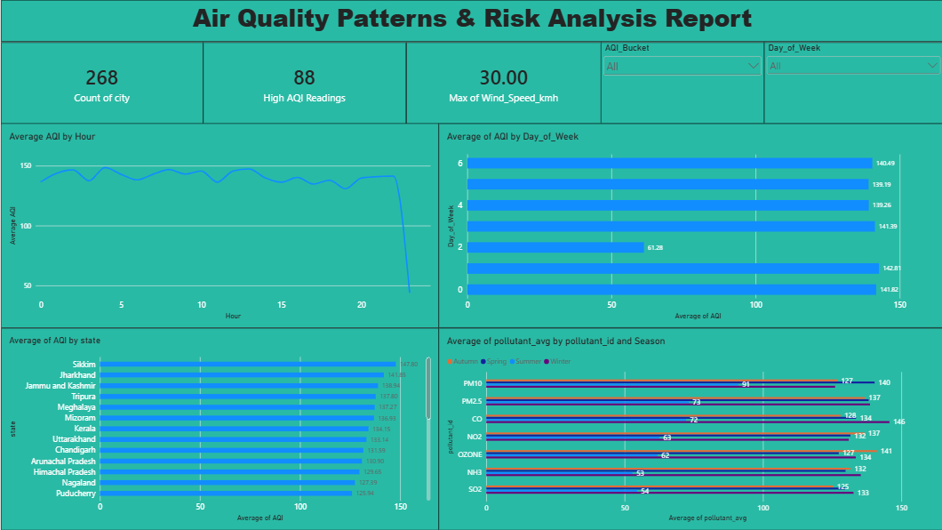
Trends Over Time: Average AQI by Hour stays fairly stable (~130–150) across the day, with a sharp drop after Hour 20 into the low 50s by Hour 23 — worth checking whether this reflects genuinely cleaner late-night air or a reporting gap.
Performance Comparisons: Average AQI by Day of Week is consistently high (~139–143) on most days, but one day (index 2) drops to 61.28 — a clear anomaly against the weekly pattern, possibly a data-collection gap or a genuine low-pollution event.
Category/Regional Distribution: Average AQI by state again places Sikkim highest (147.80), followed by Jharkhand (141.85) and Jammu and Kashmir (138.94) — consistent with the main dashboard's Decomposition Tree finding, confirming north-eastern/hill states as a recurring hotspot across multiple views.
Goal/Risk Threshold Achievement: The High AQI Readings KPI counts 88 readings flagged as high-risk out of 268 cities monitored — a concrete, trackable measure for how often the most severe threshold is breached, filterable live by AQI_Bucket and Day_of_Week via the report's slicers.

